SOLYPSIZM
Brand & Video Production Kit
v1 — drafted from Haze over the Horizon and Scatter Brained promo videos
Purpose: this is the source-of-truth document for any video produced for Solypsizm. The intent is that you (or a freelancer) can read this once and then produce on-brand content without further direction. Everything below is a starting point — edit anything that doesn't match your taste.

1. The Solypsizm Character
All ad and promo videos feature a recurring avatar. Visual consistency of this character across the campaign is the single biggest brand signal — the visor and neon piping should be instantly recognizable from a 1‑second scroll.
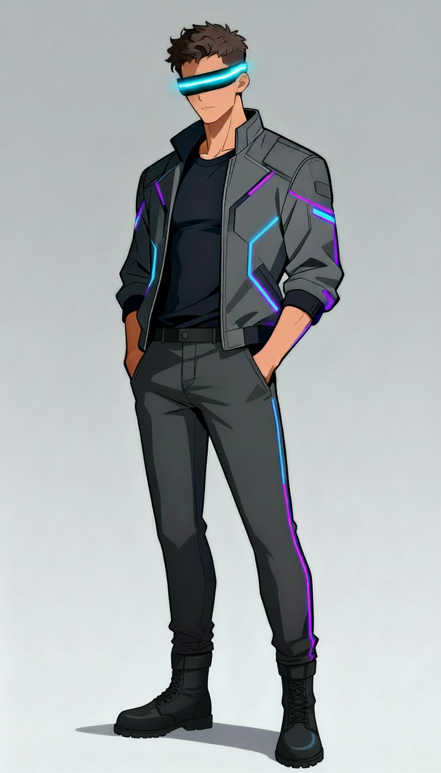
Canonical reference — front. Use as ChatGPT image-edit base for new keyframes.

Locked design specification
Style | Anime / cel-shaded illustration. Not photorealistic. Clean linework, soft cel shading, subtle volumetric glow on neon elements.
Build | Athletic young adult male, 6'0" proportions, slim-muscular.
Skin | Light tan / olive.
Hair | Short, tousled, slight quiff. Dark brown. No facial hair.
Visor | Horizontal LED-strip visor across eyes. Bright cyan core (#00D4FF) with soft glow halo. No frame or edges visible above/below the strip. Visor is always lit.
Jacket | Mid-grey bomber/varsity hybrid, geometric panel construction. Stand collar. Cyan and violet neon piping in angular hexagonal patterns across chest, shoulders, and sleeves. Rib-knit cuffs and hem in black.
Shirt | Plain black crew-neck t-shirt under jacket.
Belt | Plain black.
Pants | Slim-fit dark grey trousers. Single cyan + violet piping line down the outer leg seam, top to ankle.
Boots | Black lace-up combat / work boots, mid-ankle.
Gloves | None (most shots). Optional fingerless black gloves for action shots.

Required reference images for the keyframe library
Generate these once and save them to the Power Bin. Every Veo 3 generation should start from one of these as the seed frame.
- Front, full-body, hands at sides, neutral background
- Back, full-body, hands at sides, neutral background
- 3/4 right, full-body, hands in pockets
- 3/4 left, full-body, hands in pockets
- Walking, side profile, mid-stride
- Walking, back view, mid-stride (matches Scatter Brained shots)
- Standing on horizon road, back view, looking ahead (matches Haze shots)
- Holding phone, glow on face, head tilted down
- Mid-shot, chest up, looking at camera (visor-front)
- Close-up, head and shoulders, visor reflection visible

2. Aesthetic

Brand color palette
Solypsizm Cyan  #00D4FF | Solypsizm Violet  #8A2BE2 | Solypsizm Purple  #5B2A86
Black  #0A0A12 | Mid Grey  #3A3A42 | White  #FFFFFF

Cyan (#00D4FF) is the dominant accent — visor, jacket piping, all UI accents, lyric highlight color. Violet (#8A2BE2) is the secondary — used in piping cross-fades and atmospheric lighting. Purple (#5B2A86) is the brand purple — title cards, logo, end cards, ad CTAs.

Typography
Lyric overlay | Inter SemiBold (or Helvetica Neue Bold if Inter unavailable). 64–72pt at 1080×1920. White (#FFFFFF). 6px black drop shadow at 80% opacity. No outline. Center-aligned.
Title card | Inter SemiBold. 72pt for title, 56pt for artist line, 48pt for date. White (#FFFFFF) over dark/atmospheric background, OR brand purple (#5B2A86) over light/atmospheric background. Center-aligned.
End card | Inter Bold for primary CTA (e.g., 'STREAM NOW'). 80pt. Cyan (#00D4FF). Subline in white at 36pt.
Hashtags / @handles | Inter Regular. 32pt. White at 70% opacity.

Lyric overlay placement
- Vertical position: bottom 22% of frame (clears TikTok UI safe zone — username top-left, comment/like buttons right side)
- One line at a time. Maximum two lines if a single lyric phrase needs to break.
- On-screen for the full duration the line is sung, plus 0.2s lead-in and 0.3s tail.
- Cross-fade between lines: 6 frames at 24fps.

Color grade / look
- Crushed blacks. Lift shadows toward purple/violet.
- Highlight tint toward cyan.
- Saturation +10. Mid-tone contrast +15.
- Vignette: subtle, 15% opacity, dark purple.
- Apply the same DaVinci Resolve color preset to every clip in the campaign for visual cohesion.

3. Video Technical Specs
Aspect ratio | 9:16 vertical for TikTok / Reels / Shorts. (1:1 square optional secondary export.)
Resolution | 1080 × 1920 (HD vertical). 4K only if final destination is YouTube Shorts and you're confident the source clips hold up.
Frame rate | 24 fps (matches your reference videos and Veo 3 native output).
Promo length | 20–48 seconds. Sweet spot for ad creative is 15–30s; 45+ is ceiling before completion rate drops.
Hook window | First 1.5 seconds must establish: (a) character on-screen OR strong visual hook, (b) opening lyric line, (c) song mood. No build-up.
Audio bed | Master song stem. -14 LUFS integrated for social. Mix is from your final master, not the demo.
Codec / container | .mp4 / H.264 / AAC. Bitrate 8–12 Mbps for vertical 1080p.
Watermarks | ZERO third-party watermarks (Veo, Sora, etc.). Generate on a paid tier that strips them, or pay for an upgrade before the campaign runs.

4. Title Card & End Card

Title card (used opening 1.5–2.5s)
Visual: same atmospheric environment as the rest of the video, but darkened to ~40% so text reads. Camera holds still or pushes in slowly.
Layout, top to bottom (centered):
- [Song Title] — 72pt Inter SemiBold, white
- Solypsizm — 56pt Inter SemiBold, white
- [blank line, ~120px]
- Release [Date] — 48pt Inter SemiBold, white at 90% opacity
Animation: text fades in over 12 frames, holds for 1.5s, fades out as first vocal line begins.

End card (last 2–3s)
Visual: hero shot of avatar centered, fade to brand purple background.
- STREAM NOW — 80pt Inter Bold, cyan (#00D4FF), centered
- Solypsizm word-mark or logo, centered below
- @nicanadian — 32pt Inter Regular, white at 70% opacity, bottom-center

5. Generation Prompt Templates
These are reusable prompt skeletons. Copy, fill in the blanks, generate. Build a Notion / Apple Notes page where you keep the actual prompts you've used per song so you can re-roll without rewriting.

ChatGPT keyframe — start frame
Upload the canonical character reference (front view) as an image. Use this prompt:
Generate a vertical 1080x1920 anime-style cel-shaded illustration. The character is the man in the reference image — preserve him exactly: short brown hair, light tan skin, glowing horizontal cyan LED visor across his eyes, grey bomber jacket with cyan and violet neon piping in angular hexagonal patterns, black t-shirt, dark grey slim pants with cyan and violet piping down the side seam, black combat boots.
Scene: [DESCRIBE ENVIRONMENT — e.g., "empty foggy highway at dusk, deep purple sky, distant glowing horizon, light fog rolling across the asphalt"].
Camera: [SHOT — e.g., "low-angle wide shot, character standing center frame, back to camera, looking down the road"].
Mood: cinematic, moody, neon-lit. Crushed blacks. Cyan and violet rim lighting. No text in the image. No logos or watermarks.

ChatGPT keyframe — end frame (continuation)
Upload the start frame you just generated. Use this prompt:
Continue from this image. Same character, same environment, same lighting and color palette.
Change: [WHAT MOVES — e.g., "camera has dollied forward by 4 meters, character has taken three steps forward, horizon glow is brighter and more intense, fog has parted slightly"].
Preserve all character design details exactly. No text. No watermark.

Veo 3 (Flow Labs) motion prompt
Use the start frame and end frame above. Veo 3 prompt:
[START_FRAME] to [END_FRAME]. Camera: [MOTION — e.g., "slow dolly-in, 4 seconds"]. Subject motion: [e.g., "character walks forward steadily, jacket sways slightly with motion, neon piping glow pulses subtly with each step"]. Atmospheric motion: [e.g., "fog drifts left to right slowly, distant horizon glow pulses faintly with the bass"]. Style: cinematic anime, 24fps, no text overlay, no UI.
Tips: Veo 3 is most reliable when the start and end frames already imply the motion. Don't ask Veo to invent large motion from a static frame — it tends to morph the character. Generate intermediate frames if you need a long camera move.

6. Per-Song Theme Bibles
Each song needs its own ~10-line visual bible. These are the three from the launch. Use the same template format for any future songs.

Haze over the Horizon
Mood | Reflective, cinematic, hopeful-melancholy.
Environment | Empty asphalt road / highway, foggy purple horizon, distant rising glow, scattered stars above. Pre-dawn.
Camera | Wide, slow, contemplative. Push-ins. Few or no cuts within a clip.
Character action | Standing or walking forward. Back to camera most shots. Singular figure on the road.
Color accent | Purple-to-pink horizon, cyan visor, violet ground fog.
Pacing | Slow. 4–6 second average shot length.
Reference videos | Haze over the Horizon Promo Video.mp4 (locked standard).

Scatter Brained
Mood | Anxious, fragmented, urban.
Environment | Rainy nighttime cyberpunk city street. Wet pavement reflections. Neon shop signs. Pedestrians visible but blurred.
Camera | Tracking behind character. Dutch angles okay. Mild handheld feel acceptable.
Character action | Walking forward, lights blurring past. Occasional digital glitch dissolves on the figure.
Color accent | Magenta and red neon signage, cyan visor, blue puddle reflections.
Pacing | Faster. 2–3 second average shot length. Glitch cuts every ~4s.
Reference videos | Scatter Brained Lyric Video Promo Vertical.mp4 (locked standard).

Eat the Rich
Mood | Defiant, satirical, retro-arcade.
Environment | Synthwave grid plane, neon wireframe geometry, score/combo HUD elements, retro arcade visuals.
Camera | First-person racer / arcade game POV mixed with character reveal shots.
Character action | Character appears as the 'pilot' / 'player'. Action-oriented poses.
Color accent | Hot pink, cyan, orange — full synthwave palette.
Pacing | Punchy. 1.5–2 second average shot length.
Reference videos | Eat the Rich Promo - Vertical Tiktok.mp4.

7. Production Checklist (per video)

Pre-production
- Confirm song stem (final master, not demo) is in the project's Power Bin.
- Confirm lyric SRT exists (auto-generated via Resolve Studio Speech-to-Text or hand-written).
- Storyboard the 9 variants on the per-song shot-list template (intro hook, body shots, end card).

Generation
- ChatGPT: generate start frame using template above. Iterate until character matches reference exactly.
- ChatGPT: generate end frame as continuation.
- Flow / Veo 3: generate motion clip from start → end frame. Re-roll up to 3x; if no good take, regenerate keyframes.
- Save best clip to song's Power Bin. Tag with shot number.

Edit (DaVinci Resolve)
- Open the song's master project template (already has stem, SRT, brand color preset, title-card and end-card Fusion templates).
- Drop B-roll clips on V1 in storyboard order.
- Drop lyric overlay (already styled by template) on V2.
- Trim to song timing. Hook in first 1.5s.
- Apply brand color preset to all clips.
- Render: 1080×1920, H.264, 10 Mbps, 24fps.

Quality control
- Watch on phone (vertical), not just monitor. The phone is the actual delivery surface.
- Check that the visor color and jacket piping are unmistakably consistent with the reference.
- Confirm no AI-tool watermark visible anywhere.
- Confirm lyrics are inside TikTok safe zone (bottom 22% only).
- First-3-seconds test: would a stranger keep watching?

8. Handoff Notes for Freelancers
If you hire an editor or AI-generation specialist on Upwork/Fiverr, send them:
- This document (full).
- The character reference image folder (Cyberpunk Visor Guy.zip).
- Two reference videos: Haze over the Horizon Promo Video.mp4, Scatter Brained Lyric Video Promo Vertical.mp4.
- The song stem(s) and lyric sheet for whichever song they're working on.
- The DaVinci Resolve template project (.drp), once built.
Standard rule for them: every clip must include the avatar OR an unmistakable Solypsizm visual signature (cyan visor glow, neon piping graphic). No clip should look like generic AI B-roll without brand markers.
Approval workflow: lock your master video for each song first; freelancer produces the 8 variants from the master, sending a single review reel of all 8 stitched together for one round of notes; then individual exports.

9. Open Questions for You to Lock
Things I've made assumptions about that you should confirm or override:
- Typography — I've defaulted to Inter SemiBold. If you have a different brand font already, swap it in.
- End card CTA — I've used 'STREAM NOW'. Confirm or specify per-song (e.g., 'PRE-SAVE NOW' for unreleased).
- Logo / word-mark file — Couldn't find a final SVG/PNG of the Solypsizm word-mark in the asset folders. If you have one, drop the path here: ____________________.
- Hashtag / handle stack — Specify the standard tag-line/hashtag block to add to every video description.
- Eat the Rich theme — I locked Sora-generated synthwave as the standard. Confirm whether you want all three songs in the anime-cel-shaded style instead, or maintain the per-song stylistic split.

